|  |  |
| --- | --- |
| File:COMSATS new logo.jpg - Wikimedia Commons | **Subject:**  **Object Oriented Programming**  **submitted by:**  **Daoud hussain**  (Sp21-bcs-102)  **submitted to:**  **Mam Saneeha AAmir**  **date of submission:**  **February 28 , 2022** |

Account Class:

public class Account{

int balance,yearOfOpening;;

String cnic;

public Account(){

//Default Constructor

}

public Account(int a){

if(a>=0){

balance = a;

}

else{

balance = 0;

}

}

public Account(int a, String b, int c){

if(a>=0 && c>=0){

balance = a;

cnic = b;

yearOfOpening = c;

}else{

balance = 0;

yearOfOpening = 0;

}

}

//ReSetting values of balance

public void setValues(int a){

balance = a;

}

public int withDraw(int withdrawalValue){

if(withdrawalValue>=0){

balance = balance-withdrawalValue;

}

return balance;

}

public int deposit(int depositedValue){

if(depositedValue>=0){

balance = balance+depositedValue;

}

return balance;

}

//Giving Current year as argument

public int calculateAgeOfAccount(int currentYear){

int age=0;

if(currentYear>=yearOfOpening){

age = currentYear-yearOfOpening;

}

System.out.println("Age of Account is: " + age);

return age;

}

public void display(){

System.out.printf("Value is: \nBalance is: %d \nCnic is: %s \nYear Of Opening is %d: \n", balance, cnic, yearOfOpening);

}

}

Runner Account:

public class Runner{

public static void main(String[] args) {

Account a1 = new Account();

Account a2 = new Account(2000);

Account a3 = new Account(122, "37201-3209291-7", 2002);

a3.setValues(1500);

a3.withDraw(700);

a3.deposit(100);

a3.display();

a3.calculateAgeOfAccount(2022);

}

}

Account Output:

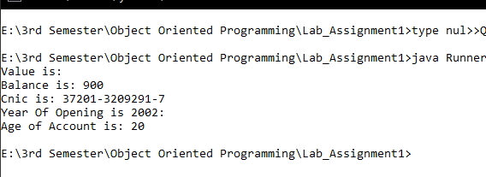

----------------------------------------

QuadraticEquation Class:

public class QuadraticEquation{

int a, b, c;

public QuadraticEquation(){

//Default Constructor

}

public QuadraticEquation(int first, int second, int third){

if(first>=0 && second>=0 && third>=0){

a=first;

b=second;

c=third;

}

}

//Reseting values of A

public void setValues(int first){

if(first>=0){

a=first;

}

}

public void display(){

System.out.printf("Value of A: %d \nValue of B: %d \nValue of C: %d \n", a,b,c);

}

public int getDiscriminant(){

int disc = b*b - 4*a*c;

return disc;

}

public boolean checkIfDescriminantIsGretaerThan100(){

if(getDiscriminant()>100){

return true;

}

else{

return false;

}

}

}

Runner QuadraticEquation:

public class Runner{

public static void main(String[] args) {

QuadraticEquation a1 = new QuadraticEquation(); //Setting default values

QuadraticEquation a2 = new QuadraticEquation(122,222,322); //Argument Values

a2.setValues(100);

a2.display();

a2.getDiscriminant();

}

}

QuadraticEquation Output:

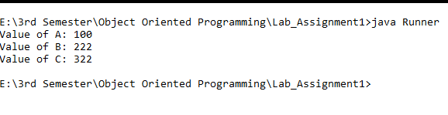

----------------------------------------

Rectangle Class:

public class Rectangle{

int length,width;

public Rectangle(){

//Default Constructor

}

//2 Argument Constructor

public Rectangle(int a,int b){

if(a>=0 && b>=0){

length = a;

width = b;

}

//ReSetting values of length

public void setValues(int newValue){

if(newValue>=0){

length = newValue;

}

}

public int calculateArea(){

int area = length*width;

return area;

}

public boolean checkSquare(){

if(length==width){

return true;

}

else{

return false;

}

}

public void display(){

System.out.printf("Value of Length: %d \nValue of Width: %d ", length,width);

}

}

Runner Rectangle:

public class Runner{

public static void main(String[] args) {

Rectangle a1 = new Rectangle(); //Setting default values

Rectangle a2 = new Rectangle(122,222); //2 Argument Values

a2.setValues(100);

a2.calculateArea();

a2.checkSquare();

a2.display();

}

}

Rectangle Output:

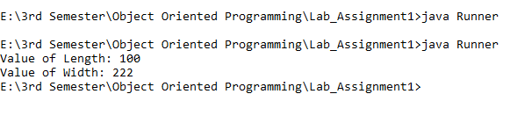

----------------------------------------

Point Class:

public class Point{

int x, y;

public Point(){

//Default Constructor

}

//2 argument Constructor

public Point(int a, int b){

x = a;

y = b;

}

public void display(){

System.out.printf("Value of A: %d and Value of B: %d", x, y);

}

public void setValues(int a){

x = a;

}

//a and b are the points that how far you move in x and y coordinates

public void move(int a, int b){

x = a+x;

y = b+y;

}

public boolean checkOrigin(){

if(x==0 && y==0){

return true;

}

else{

return false;

}

}

}

Point Runner:

public class Runner{

public static void main(String[] args) {

Point a1 = new Point(); //Setting default values

Point a2 = new Point(-1,3); //2 Argument Values

a2.setValues(2);

a2.move(3,4);

a2.checkOrigin();

a2.display();

}

}

Point Output:

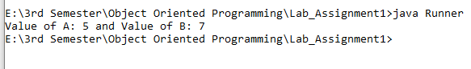

----------------------------------------

Book Class:

public class Book{

String author = "";

String chapterNames[] = new String[5];

public Book(){

//Default Constructor

}

//2 argument Constructor

public Book(String a, String[] b ){

author = a;

for (int i=0; i<=4 ;i++ ) {

chapterNames[i] = b[i];

}

}

public void display(){

System.out.printf("Name of Authos is: %s", author);

System.out.println(" And Chapter names are: ");

for (int i=0; i<=4 ;i++ ) {

System.out.println(chapterNames[i]);

}

}

//Reseting name of Author

public void setValue(String a){

author = a;

}

public boolean checkIfAuthorNameStartsWithA(){

if(author.startsWith("A"))

return true;

else{

return false;

}

}

public boolean searchChapter(String abc){

boolean flag = false;

for (int i=0; i<=4 ;i++ ) {

//CompareTo method compares two strings and return 0 if they are equal

if(chapterNames[i].compareTo(abc) == 0){

flag = true;

break;

}

else{

flag = false;

}

}

if(flag){

return true;

}

else{

return false;

}

}

}

Book Runner:

public class Runner{

public static void main(String[] args) {

String[] arr= {"Introduction","Sequence","Selection","Repetititon","Functions"};

Book a1 = new Book(); //Setting default values

Book a2 = new Book("Rizwan Rashid", arr); //2 Argument Values

//Reseting Author name

a2.setValue("Saneeha Aamir");

a2.display();

a2.checkIfAuthorNameStartsWithA();

a2.searchChapter("Programming");

}

Book Output:

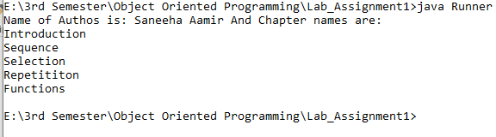

Student Class:

public class Student{

double gpa;

String[] Subjects = new String[5];

String name,email;

public Student(){

//Default Constructor

}

public Student(double g, String n, String e, String[] s){

if(g>=0.0 && e!="" && n!=""){

gpa = g;

email = e;

name = n;

}

else{

gpa=0.0;

}

if(s.length>=Subjects.length){

for (int i=0; i<Subjects.length-1 ;i++ ) {

Subjects[i] = s[i];

}

}

else{

for (int i=0; i<s.length-1 ;i++ ) {

Subjects[i] = s[i];

}

}

}

//ReSetting values of Name

public void setValues(String n){

if(n!=""){

name = n;

}

}

public boolean searchSubject(String subjectName){

boolean flag = false;

for(int i=0; i<Subjects.length-1; i++){

if(subjectName==Subjects[i]){

flag = true;

}

else{

flag = false;

}

}

if(flag){

return true;

}

else{

return false;

}

}

public boolean checkProbStatus(){

if(gpa<2.0)

return true;

else{

return false;

}

}

public boolean validateEmail(){

String validEmail = "@gmail.com";

if(email.contains(validEmail)){

return true;

}

else{

return false;

}

}

public void display(){

System.out.printf("Records are: \nName: %s\nGPA: %5.2f\nEmail: %s \nSubjects: ", name, gpa, email);

for(int i=0; i<Subjects.length-1;i++){

if(Subjects[i]!=null){

System.out.print(Subjects[i] + " ");

}

}

}

}

Student Runner:

public class Runner{

public static void main(String[] args) {

String[] arr= {"OOP","DSA","Multi-Calculas","Genetics","Communication Skills"};

Student a1 = new Student(); //Setting default values

Student a2 = new Student(3.4, "Sameem", "daoudhussain302@gmail.com", arr); //2 Argument Values

//Reseting Student name

a2.setValues("Daoud");

a2.display();

a2.checkProbStatus();

a2.validateEmail();

a2.searchSubject("OOP");

}

}

Student Output:

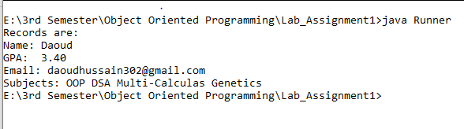

University Class:

public class University{

String[] departments = new String[20];

String uniName, location, rectorName;

public University(){

//Default Constructor

}

//Two-Argument Constructor

public University(String a,String b){

if(a!="" && b!=""){

uniName = a;

location = b;

}

}

//Full-Argument Constructor

public University(String a,String b, String c, String[] s){

if(a!="" && b!="" && c!=""){

uniName = a;

location = b;

rectorName = c;

}

if(s.length < departments.length){

for(int i=0; i<s.length; i++){

departments[i] = s[i];

}

}

else{

for(int i=0; i<departments.length; i++){

departments[i] = s[i];

}

}

}

//Method to Add a department

public void addADepartment(){

for(int i=0; i<departments.length; i++){

if(departments[i] == null){

departments[i] = "EE";

break;

}

}

}

//Method to check whether the location provided is in Islamabad or not

public boolean checkIfLocatedInCapital(){

if(location == "Islamabad"){

return true;

}

else{

return false;

}

}

//Method to check whether the EE department is present or not

public boolean searchDepartment(){

boolean flag = false;

for(int i=0; i<departments.length;i++){

if(departments[i] == "CS"){

flag = true;

}

}

if(flag){

return true;

}

else{

return false;

}

}

//Method to display all the values

public void display(){

System.out.println("UNIVERSITY NAME: " + uniName+ "\n" + "LOCATION: " + location + "\n"+ "RECTOR NAME: " + rectorName +"\n"+ "DEPARTMETNS");

for(int i=0; i<departments.length;i++){

if(departments[i]!=null){

System.out.print(i+1+"." + departments[i] + "\n");

}

}

}

}

University Runner:

public class Runner{

public static void main(String[] args) {

String[] arr= {"CE","CS" ,"Cyber Security","AI","DS","SE","Maths","Bio-Informatics","Physics","BBA","English","Economics", "BAF", "Political Science", "IR","Chemistry","Bio-Tech","Pharm","IT"};

University a1 = new University(); //Setting default values

University a2 = new University("Hamdard","Islamabad"); //2 Argument constructor

University a3 = new University("COMSATS", "Islamabad", " Fazal Mehmood", arr); //Full Argument Constructor

a3.checkIfLocatedInCapital();

a3.searchDepartment();

a3.addADepartment();

a3.display();

}

}

University Output:



